

Dynamics 365 – Fair and CoC Management

Revision 1
Revision History

Date | Revision | Description | Signature / Date
27/09/2022 | 1 | Initial draft of user manual: Dynamics 365 – FAIR and CoC Management | Prepared | Waseem Abbas
 |  |  | Verified
 |  |  | Approved
 |  |  | Prepared
 |  |  | Verified
 |  |  | Approved
 |  |  | Prepared

Table of Contents
1 About User Manual 5
1.1 Dashboard Overview 5
1.2 FAIR, CoC Management Workspace 5
1.3 Click on Vendor Specific FAIR and COC 6
1.4 Vendor Specific FAIR and COC Management 7
1.5 Add Vendor Account 7
1.6 Select Vendor Specific Product Variant 8
1.7 Open the Product Variant 8
1.8 Product Variant Detail section 8
1.9 Final Calculation of Vendor Specific FAIR and COC 9

List of Figures
Figure 1. Important in Dashboard 5
Figure 2. FAIR, CoC Management Workspace 6
Figure 3 Click on Vendor Specific FAIR COC 6
Figure 4 Vendor Specific FAIR COC Calculations 7
Figure 5 Add Vendor Account 7
Figure 6 Select Vendor Specific Product Variant 8
Figure 7 Open the Product Variant 8
Figure 8 Product Variant Detail section 9
Figure 9 Final Calculation of Vendor Specific FAIR and COC 9

About User Manual
This document describes the step-by-step guide of manually creation of a FAIR and CoC management of a product or a list of sub-products (items). This FAIR and CoC requirement are typically set by a purchase user (employee) in a legal entity (legal organization). The purchase user forwards the purchase order (PO) to a vendor who has been chosen (selected) for that product through purchase requisition bidding process.
The step-by-step guide of a FAIR and CoC management will be explained.

Dashboard Overview
After logging in, you will see the main dashboard which includes the grid of individual Workspaces (in the middle), which are represented in the Figure 1. The purchase user can see a list of important processes related to FAIR and CoC management in the vendor section under procurement and sourcing in the Modules.
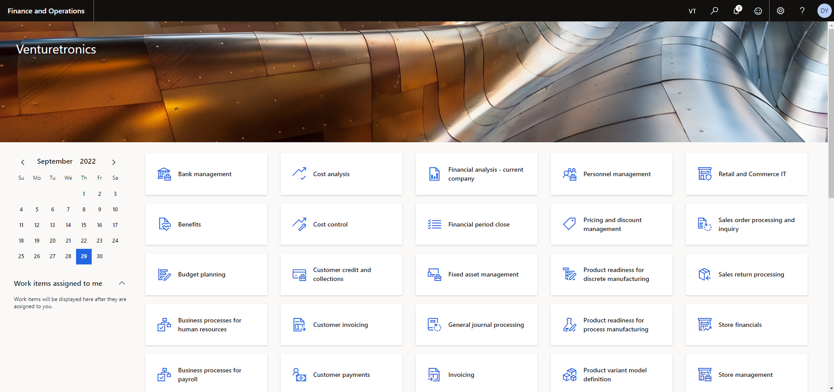
Figure 1. Important in Dashboard

FAIR, CoC Management Workspace
There are various ways to access the fair from workspace.
Approach: From Modules Icon
The user can also access the vendors page(s) by clicking the Modules, select Procurement and Sourcing and then Purchase Orders group. After clicking the All Vendors link in vendors group, following information will appear which is shown in the Figure 2.
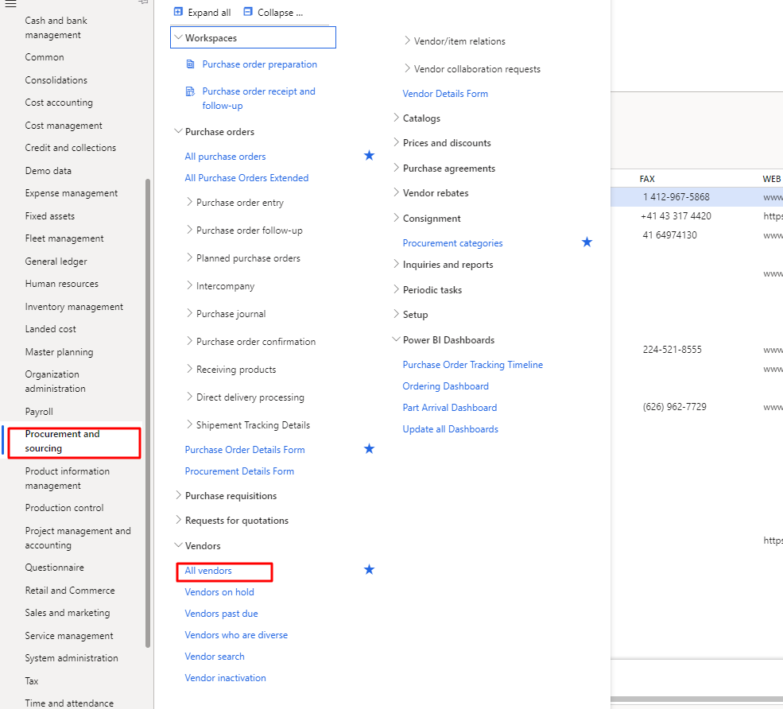
Figure 2. FAIR, and CoC Management Workspace

Click on Vendor Specific FAIR and COC
The users can see all the vendors in this section. User need to select any vendor under standard view then click on “Vendor Specific FAIR and COC”. Process is also shown in the below Figure 3.
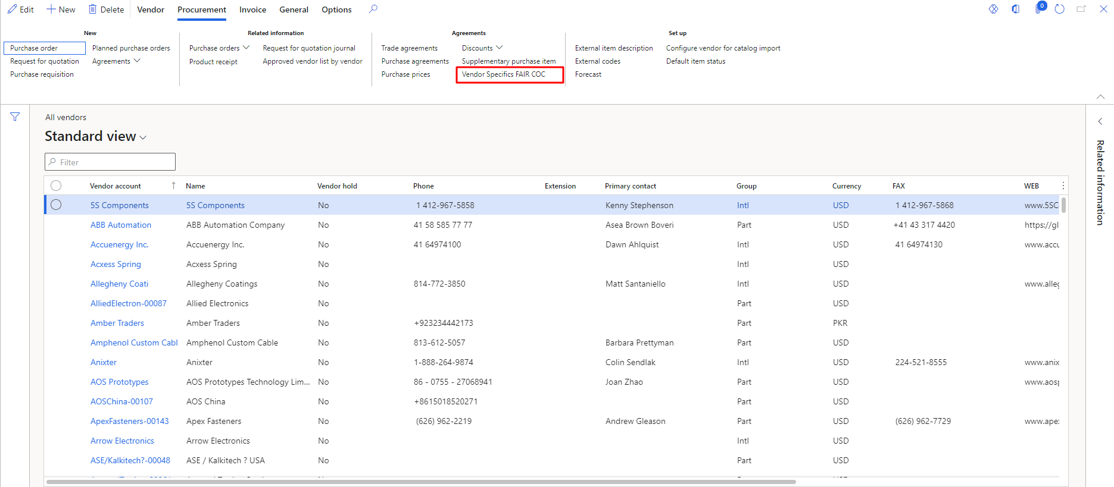
Figure 3 Click on Vendor Specific FAIR COC

Vendor Specific FAIR and COC Management
When you click on the vendor specific FAIR COC then you will be able to view this page. In this section, user can create new Vendor Specific FAIR and COC and delete it by clicking on it. The user can refresh each row by clicking on the Refresh Grid button. Here, user will add the vendor account in the ‘Vendor Account No’ field. Process is also shown in the below Figure 4.
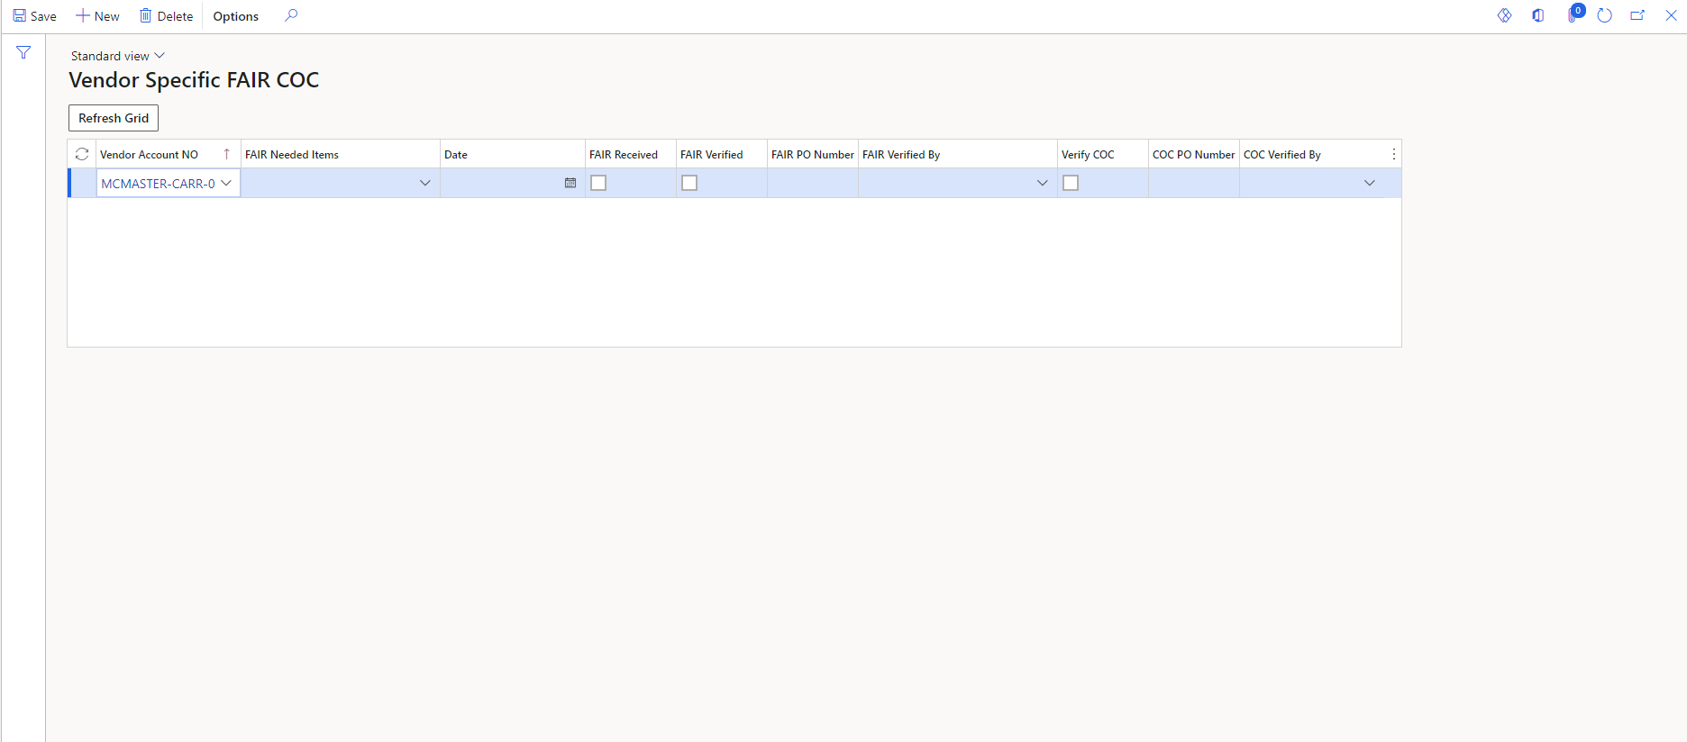
Figure 4 Vendor Specific FAIR COC Calculations

Add Vendor Account
The user can also access the FAIR Calculation page by clicking on the Vendor Specific FAIR COC from vendors. The user can add the specific vendor in the vendor account fields. In the first time, FAIR Verified and COC PO Number will be disable. The user needs to enable it in the Product Variant module. Process is also shown in the below Figure 4.
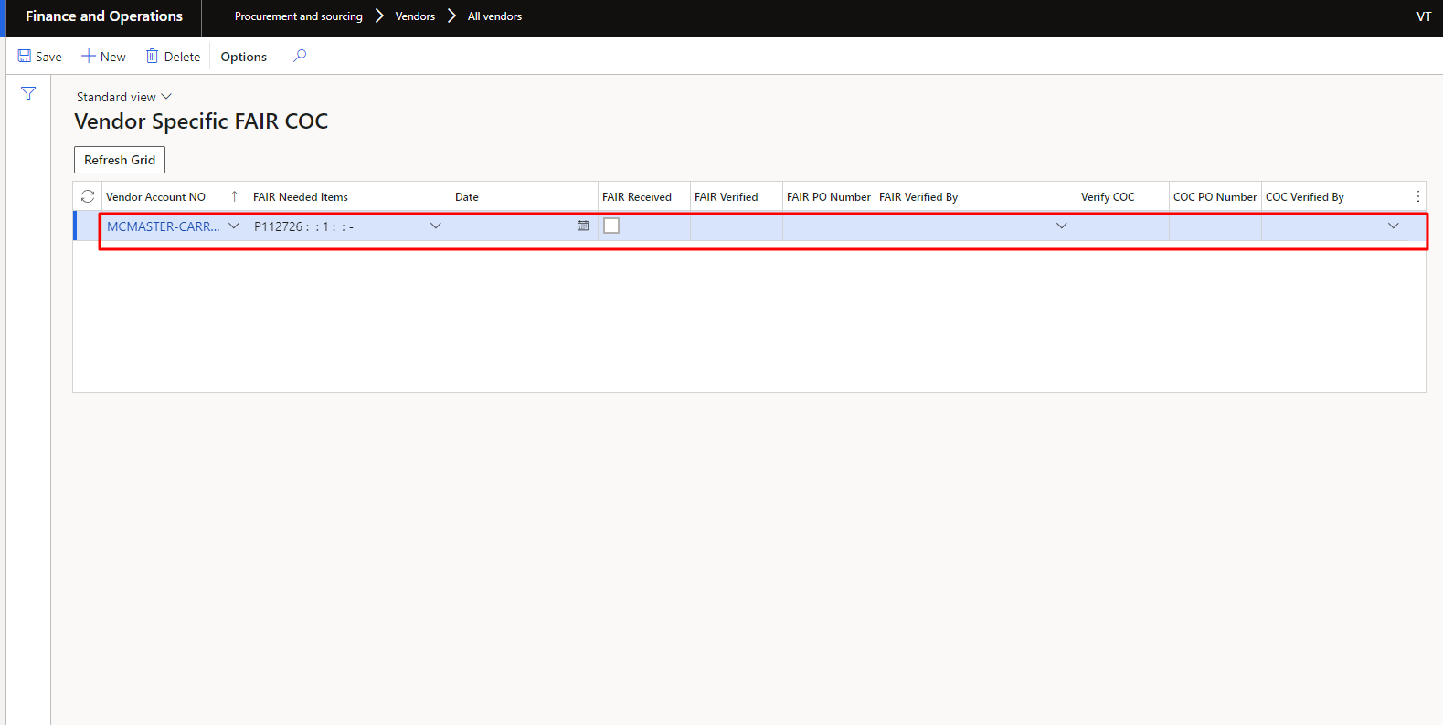
Figure 5 Add Vendor Account

Select Vendor Specific Product Variant
The user can also access the Product page by clicking the ‘Product Information Management’ module. The user needs to search the specific vendor related product in the search fields. Process is also shown in the below Figure 6.
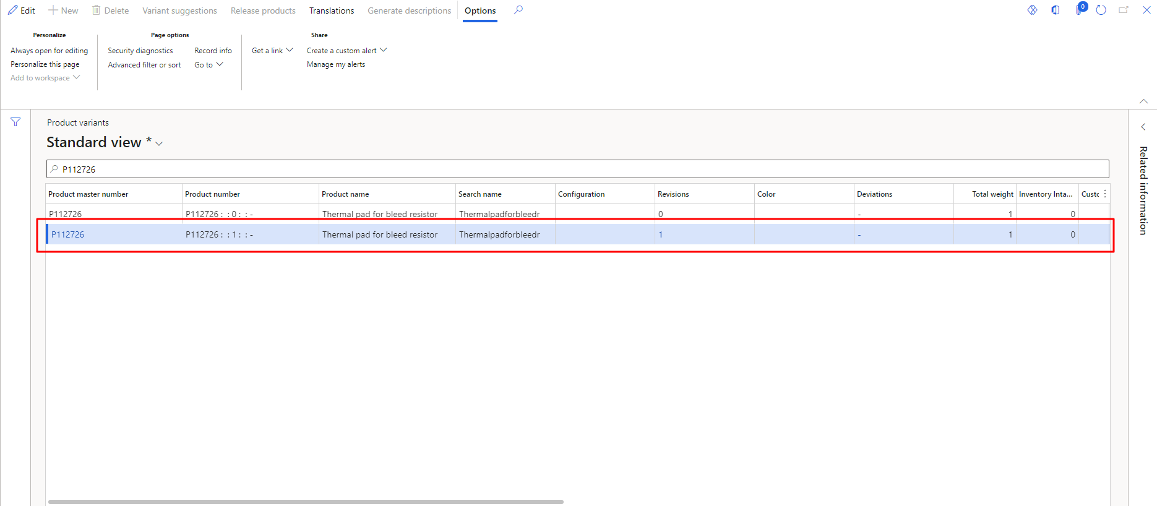
Figure 6 Select Vendor Specific Product Variant

Open the Product Variant
The user can also access the ‘Product Variant’ page by clicking on the specific vendor related product. The user needs to click on the product variant from top header. Process is also shown in the below Figure 7.
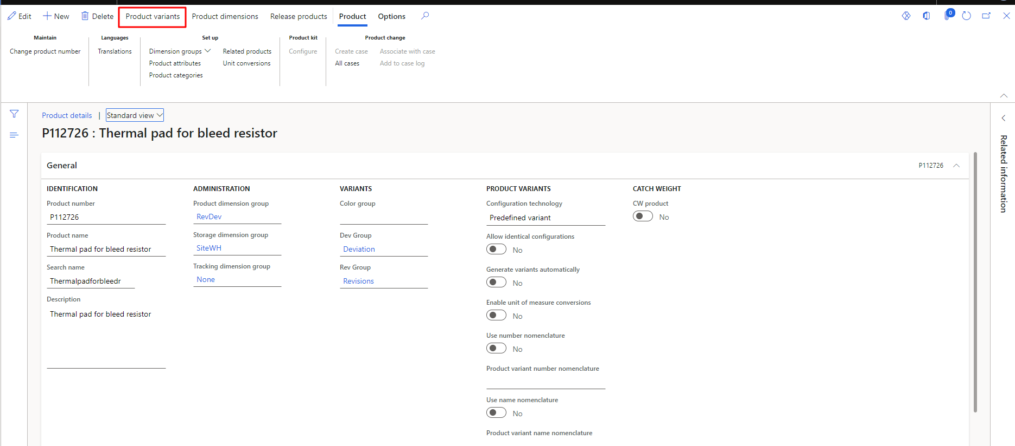
Figure 7 Open the Product Variant

Product Variant Detail section
The user can also access the ‘Product Variant Detail’ page by clicking on the ‘Product Variant’. The user needs to click on the specific vendor related product after selecting product variant. The user needs to enable the FAIR Verified and COC PO Number from the general section. Process is also shown in the below Figure 8.

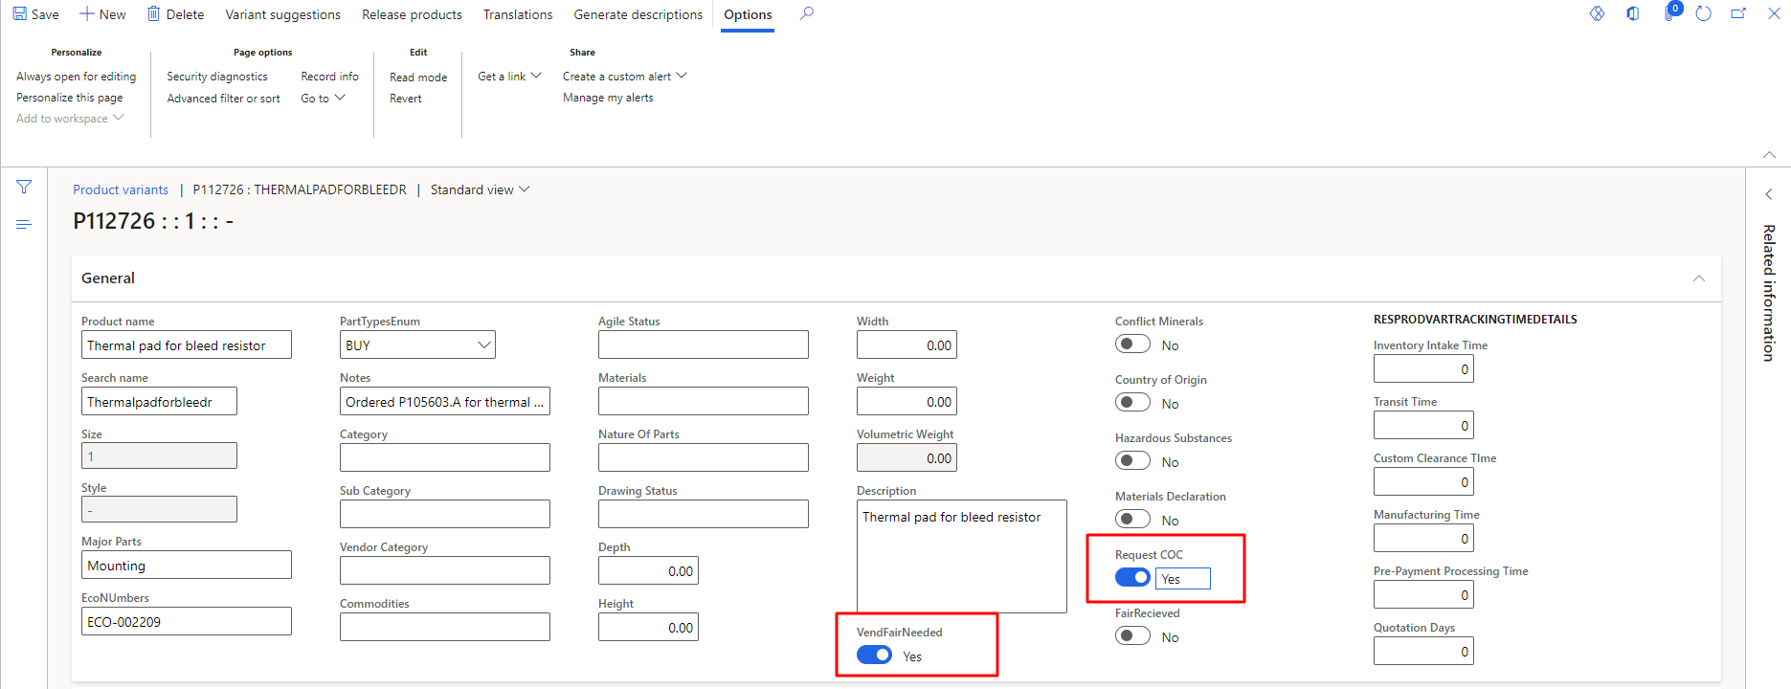
Figure 8 Product Variant Detail section

Final Calculation of Vendor Specific FAIR and COC
The user can also access the FAIR Calculation page by clicking the vendor Specific FAIR and COC from vendors. The user can add the specific vendor in the vendor account fields. In the first time, ‘FAIR Verified and COC PO Number’ will be disable. In the ‘FAIR Needed Items’ user can only see the approved item from the selected vendor account. As the user enabled these fields from product variant then user can view these check boxes. Process is also shown in the below Figure 9.
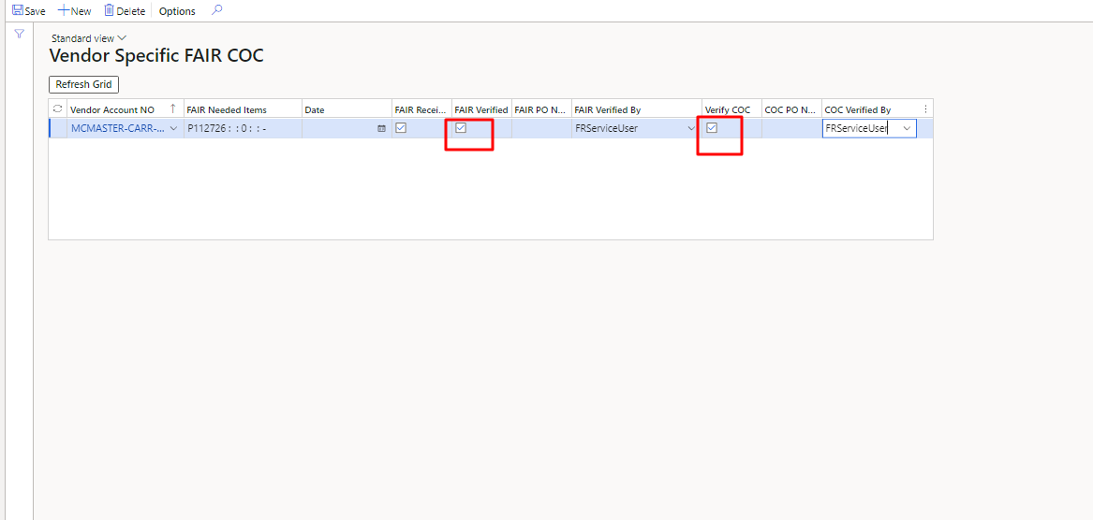
Figure 9 Final Calculation of Vendor Specific FAIR and COC

